No Shows & Maximizing Show Rates (Setter Levers)
In this video, we're going to break down every single lever you can pull as a setter to fix your show rate and maximize the throughput of your entire acquisition funnel. This is specifically for setters - the levers that are directly in your control to get more people showing up to calls, which means more commission in your pocket.

What We're Going To Cover:
- Why Show Rate Matters For Setters
- The Intro Call Reality
- Manual Confirmation Protocol
- No Show Protocol

Why Show Rate Matters For Setters
- If you're running a 2-call process, prioritizing show rates is literally the difference between making money and being broke.
  - More intros you take = more sets that convert to demos = more closes = more commission for you.

- On the demo call, it's also your responsibility to maximize show rates because this ties directly into you making more money:
  - More shows = more offers = more closes = more commission

Some levers for show rate are in your control, others aren't. In this video, we're showing you all the levers in your direct control as a setter and what to do if/when someone no shows.

Keep top of mind from here on out that as a setter your #1 priority is maximizing show rates on both intro calls and demo calls.

The Intro Call Reality
- Here's something most setters get wrong - never see the intro call leads book as the true call time.
  - The intro's goal is to pre-qualify and educate the lead prior to the demo call. The sooner we can do those 2 things, the better.

- Therefore, regardless of what time the intro is booked, you must be calling ASAP to take that intro
  - Get scrappy with this - the intro they book is just a PLACEHOLDER, not the true time you should wait until to call them
    - At any opportunity you can, get on the phone with them, take the intro and book them in for a demo ASAP
      - Success loves speed, and speed-to-lead is KEY here
  - I’ve seen many setters shit their pants when they start doing this because some prospects will give pushback and say “I booked for X time why are you calling me now!?” but this is the same thing you get with speed to lead and call consistency
    - If you call leads 5x in one day, you get 3 more people booking but 1 of them gets pissed off, it’s worth the tradeoff: exact same applies here.
      - This also comes down to how you FRAME the call when you call them prior to the scheduled time

The Framing Script
"Yeah man, I know, I'm calling you prior to our scheduled time. I just wanted to call you now to see if it's a good fit, save us time on the call so we can hit the ground running. Is that fair?"

Always frame you giving them a call prior to the scheduled time as in their best interest, your goal as a setter is to do TWO things prior to the demo call:
- Qualify the lead
- Increase show rate
  - Therefore in order to do so you must CONDENSE the sales cycle by pushing all calls forward and by getting them on a demo as soon as humanly possible

Manual Confirmation Protocol
Regardless of if the person is booking an intro or not (1-call or 2-call process), you should be calling prior to ensure they show up.

Manual confirmation over the phone has been shown to increase show rate by 30%+ so this is one of the highest leverage things you can do.

When Connecting With Them Over The Phone:
- Always double tie down on their time
  - "So you're confirmed for Tuesday at 2pm, you'll be there right?"
  - "Perfect, and you'll have your calendar open and be ready to dive in?"

- Attempt to push the demo call time forward (within next 24hrs is ideal)
  - "Actually, I've got a slot that just opened up tomorrow morning at 10am, would that work better?"
- Send sales assets to build trust pre-call
  - Case studies, testimonials, anything that builds credibility
- Conduct mini pre-pitch (covered in "Transitioning to Demo" video)

24-Hour Unresponsive Protocol
If someone is unresponsive 24hrs prior to their call, always get them on multiple channels:

- WhatsApp: Text, voice note, video outreach (personalized)
- Instagram: Follow them and DM them there
  - Make sure your IG has case studies and social proof on it
- Follow everything covered in Lead Nurture Best Practices

Daily Calendar Audit:
- At the end of each day, audit both your and the closer's calendar
  - Clear out any unqualified appointments or mark them as free
  - Grade 1-2 apps always marked as free to make space for more qualified prospects

No Show Protocol
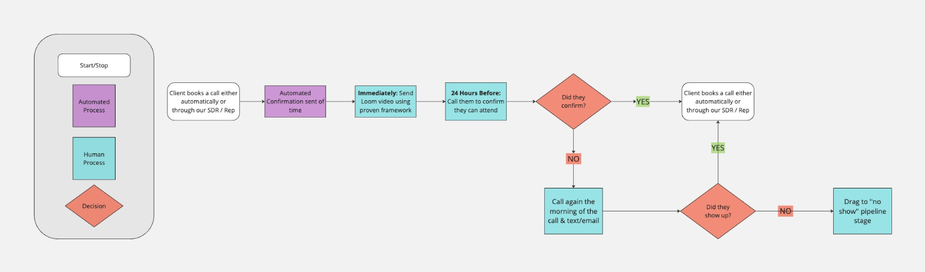
When someone doesn't show up, here's exactly what you do:

Wait for 3 minutes to allow time for them to hop on.

- Call the number attached to the lead
  - If no answer: double dial immediately
  - If no answer to both double dials: send first text
- Call the front desk (look up the front desk number on Google if it's within business hours)
  - Ask for the person who booked the call and say they booked you in for a "client generation call"
    - Always frame this call as if the owner reached out to you and was expecting your call now

7 Minutes Past Call Time:

- 3rd call from GHL number
- Call from personal phone number
- Send the Jeremy Miner text:
  - "Hey it's [NAME] from [COMPANY], we had a call for [TIME] to get you more [CLIENT TYPE], tried to call you a few times and never heard back... where should we go from here?"
- Move them to the no-show pipeline stage

10 Minutes Past Call Time:

- Send final text:
  - "Hey [NAME], called a few times. Are you interested in rescheduling?"

If Still No Response:

Follow your chain of priority list immediately upon someone no showing, while simultaneously completing the steps above

DO NOT think that because you've got a no show this is "throwaway" time and you sit there like a jackass doing nothing. This is the perfect opportunity to go through the priority chain and follow up with other leads or push other calls forward to take them there and then.

Pipeline Management
Once someone no-shows, they automatically move into:
- Email and text sequence
- Slack notification every 24 hours for the first few days to follow up and call them
- You only move the lead out of no-show if they rebook
  - Otherwise, they automatically get added to long-term nurture over a longer period of time

